**DAILY ONLINE ACTIVITIES SUMMARY**

|  |  |  |  |  |  |  |  |  |
| --- | --- | --- | --- | --- | --- | --- | --- | --- |
| **Date:** | **21-5-2020** | | | | | **Name:** | **poojashree** | |
| **Sem & Sec** | **8th sem A sec** | | | | | **USN:** | **4al16cs065** | |
| **Online Test Summary** | | | | | | | | |
| **Subject** | | **SMS** | | | | | | |
| **Max. Marks** | | **60** | | **Score** | | | **28** | |
| **Certification Course Summary** | | | | | | | | |
| **Course** | **Introduction to ethical hacking** | | | | | | | |
| **Certificate Provider** | | | **Great learning academy** | | **Duration** | | | **6.5hr** |
| **Coding Challenges** | | | | | | | | |
| **Problem Statement:** **1.** **Python program in number right angled triangle.**  **2.printing the rotation of the a list element** | | | | | | | | |
| **Status:completed** | | | | | | | | |
| **Uploaded the report in Github** | | | | | **yes** | | | |
| **If yes Repository name** | | | | | **Poojashree1998** | | | |
| **Uploaded the report in slack** | | | | | **yes** | | | |

**Online test**

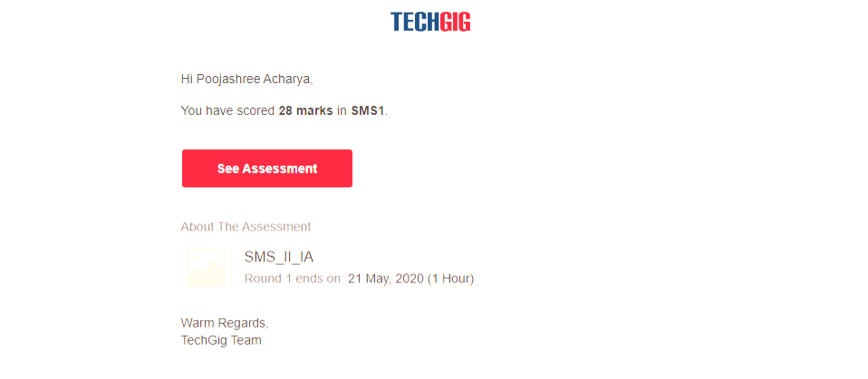

**Certification course**

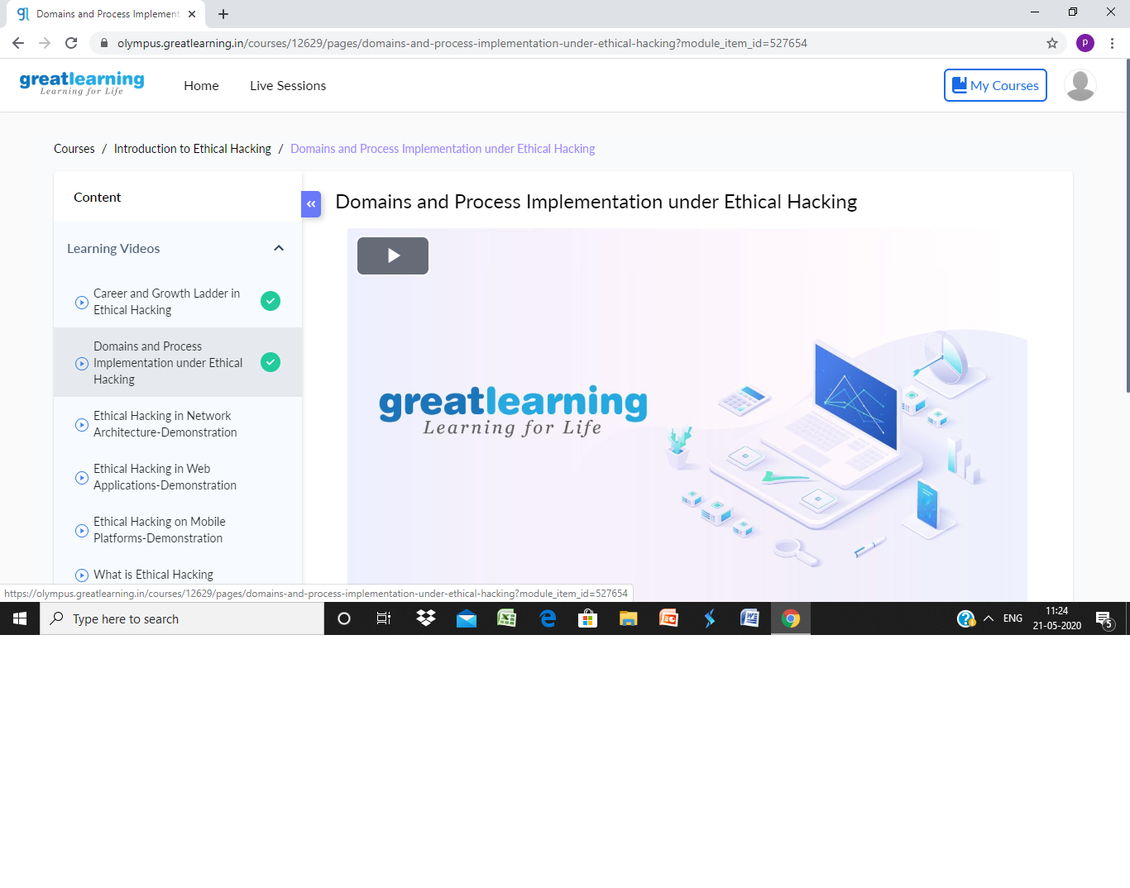

Coding

**Program 1**

Top of Form

Bottom of Form

Top of Form

Bottom of Form

|  |  |
| --- | --- |
|  | def rightRotate(lists, num): |
|  | output_list = [] |
|  |  |
|  |  |
|  | for item in range(len(lists) - num, len(lists)): |
|  | output_list.append(lists[item]) |
|  |  |
|  | for item in range(0, len(lists) - num): |
|  | output_list.append(lists[item]) |
|  |  |
|  | return output_list |
|  |  |
|  | rotate_num = 3 |
|  | list_1 = [1, 2, 3, 4, 5, 6] |

**Coding 2**

|  |
| --- |
| rows = int(input("enter number of rows ")) |
|  | for i in range(0, rows + 1): |
|  | for j in range(rows - i, 0, -1): |
|  | print(j, end=' ') |
|  | print() |